Adventure Works Database Analysis
This project involves analyzing business data from Adventure Works company to uncover insights into sales, product performance and customer behavior. I took into consideration indicators such as sales, profit, profit margin, total cost or total transactions.

Key Business Questions I want to investigate in my project:
- Which product categories and subcategories generate the most revenue? What was the most popular product in 2005 – 2008?
- How do sales trends vary by sales region and customer demographics?
- What are the seasonal patterns in product demand?
- When was the Peak Sales Period?
- Did the temperature range have an impact on the sales volume?

Project Sequence :
- Data selection and preparation in Excel
- Loading the data into Power BI Desktop and data cleaning in Power Query Editor
- Data modelling
- Calculated columns
- DAX measures
- Data visualization and analysis

Ad 1) Data selection and preparation in Excel
- I took the Power BI file used during the DAX training session organized by the Adventure Works company. I copied the contents of the tables to the Excel file (every table to the different sheet) to be able to transform the data in Power Query Editor.

Ad 2) Loading data into Power BI Desktop and transforming data in Power Query Editor:
- I loaded the database created in Excel to Power BI Desktop
- In each table I chose the necessary columns for the analysis (option Choose columns in Power Query Editor)
- I checked and corrected the data types if necessary
- I removed empty rows
- I checked the column quality for all the columns in the data model to make sure that it was always: 100% valid, 0% error and 0% empty:
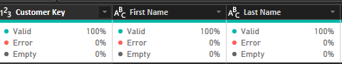
Ad 3) Data modeling in Power BI Desktop:
- Data modelling consists of creating relationships between the tables. It is necessary to be able to analyze different pieces of data together.

- I created one-to-many relationships between the tables (or corrected the automatically created relationships by Power B) in the following manner:

  - Relationship between dimension and fact tables: dimension table was 1-side of a relationship and fact table many-side of a relationship

  - Relationship between dimension tables: CategSubcateg (1-side) and Product (many-side)

  - Relationship between dimension tables: Geography (1-side) and Customer (many-side)

- The tables inserted into Power BI Desktop at the beginning of the project were the following:

Fact table: Internet Sales (The fact table contains quantitative information usually numeric and additive such as sales, cost, profit, profit margin)

The following dimension tables (contain descriptive values):
  - Product
  - Date
  - Sales Territory
  - Temperature
  - Customer

- I created the following tables:

  - Geography
I duplicated the table Customer in Power Query Editor, then I renamed the new table as Geography and I chose columns in Geography table. I added a new column to Geography table (Index column from 1) – I changed the name of the new column to Geography key. In the Customer table I merged 2 queries (Customer and Geography) by the columns CustomerCity, CustomerState and Customer Country. I checked the relationships between the tables Geography and Customer.
  - CategSubcateg
I duplicated the table Product in Power Query Editor, then I renamed the new table as CategSubcateg and I chose columns in CategSubcateg table. I added a new column to CategSubcateg table (Index column from 1) – I changed the name of the new column to CategSubCateg Key. In the table Product I merged 2 queries (Product and CategSubcateg) by the columns Category and SubCategory. I checked the relationships between the tables Product and CategSubcateg.

- The model that I created is a snowflake schema: the tables CategSubcateg and Geography are not connected directly to the fact table (Internet Sales). The connections are as follows:
  - CategSubcateg => Product => Internet Sales
  - Geography => Customer => Internet Sales

- I marked Date table as date table

- The relationships created in data model are as follows:

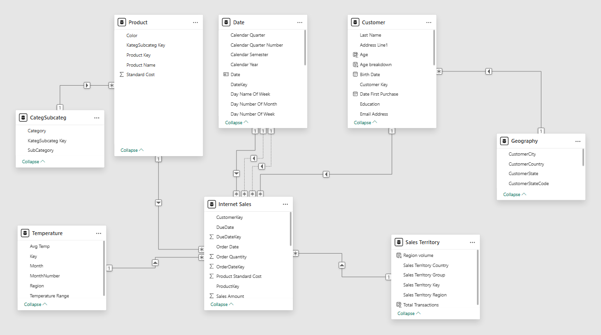

- The active relationship between Date table and Internet Sales table was created by Order Date:

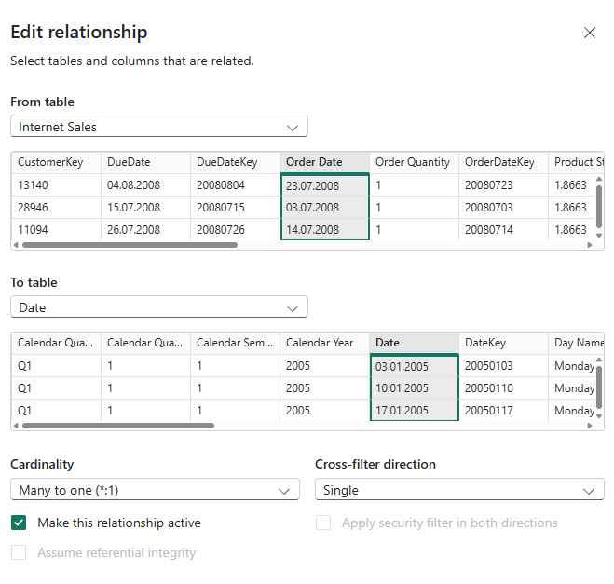
Ad 4) Calculated columns
I inserted calculated columns in the following tables:
- Customer: Age, Age breakdown, Full name, Income breakdown, Last purchase date, Number of transactions, Sum of sales
- Internet Sales: Sales amount as CC, Temperature key (I have then created the relationship between the tables Temperature and Internet Sales)
- Sales Territory: Total Transactions
Ad 5) DAX measures
I inserted the following DAX measures into the Internet Sales table:

- Total Sales = SUM('Internet Sales'[Sales Amount])
This is calculated by adding all the Sales Amount in the Internet Sales table. I used the DAX ‘SUM’ function to perform this operation.

- Total Cost = SUM('Internet Sales'[Total Product Cost])
This is calculated by adding all the Total Product Cost in the Internet Sales table.

- Profit = [Total Sales] - [Total Cost]
Profit is calculated by subtracting the Total Cost from the Total Sales (in this calculation I used the measures already created.

- Profit Margin = DIVIDE([Profit], [Total Sales])
This is calculated by dividing the Profit by Total Sales. Here I used the DIVIDE function, this function takes two parameters (numerator and denominator) and an alternative in case the denominator is zero or blank.

- Total Customers = DISTINCTCOUNT('Customer'[Full Name])
I used the DISTINCTCOUNT function to count the total customers. Distinct makes sure there are no duplicate customers.

- Total Sales PY (SPLY) =
CALCULATE(
[Total Sales],
SAMEPERIODLASTYEAR('Date'[Date] ))

I calculated Total Sales for the same period of the previous year. To do this, I used 2 DAX functions:

CALCULATE – Evaluates an expression (in this case it is Total Sales) in the modified filter context

SAMEPERIODLASTYEAR – one of the Time Intelligence functions in DAX. When used as a second parameter of the CALCULATE function, it is used as a filter modifier. This function takes a single parameter (Date).
SAMEPERIODLASTYEAR returns the period for the last year, taking into consideration the current filter context – for example:
    - Current filter context = year 2007 => CALCULATE with SAMEPERIODLASTYEAR as a second parameter returns Total sales for year 2006
    - Current filter context = Q4 (quarter 4) of year 2007 => CALCULATE with SAMEPERIODLASTYEAR as a second parameter returns Total sales for Q4 of year 2006
    - Current filter context = December 2007 => CALCULATE with SAMEPERIODLASTYEAR as a second parameter returns Total sales for December 2006

- Total Transactions = COUNTROWS('Internet Sales')
COUNTROWS is a function that counts the number of rows in a table

- Total Transactions PY (SPLY) =
CALCULATE(
[Total Transactions],
SAMEPERIODLASTYEAR('Date'[Date] ))

I calculated Total Transactions for the same period of the previous year. I used the same functions as in measure Total Sales PY (SPLY): CALCULATE and SAMEPERIODLASTYEAR.

- YTD Sales =
TOTALYTD(
[Total Sales],
'Date'[Date] )

TOTALYTD is another Time Intelligence function in DAX. This function evaluates the specified expression (in this case Total sales) over the interval which begins on the first day of the year and ends with the last date in the specified date column after applying specified filters.

- YTD Sales PY (SPLY) =
CALCULATE(
[YTD Sales],
SAMEPERIODLASTYEAR('Date'[Date] ))

I calculated YTD Sales for the same period of the previous year. I used the same functions as in measure Total Sales PY (SPLY): CALCULATE and SAMEPERIODLASTYEAR.

Ad 6) Data visualization and analysis
The Dashboard that I created consists of 5 pages: Sales Overview; Performance; Product Details; Customer; Sales Territory Country (Drillthrough).
Important assumption: In the model sales were generated between July 2005 and July 2008. In the analysis I take into consideration calendar years (between January and December) and not fiscal years.
Table with sales details across time is presented below:
Calendar Year | Calendar Quarter | Month | Total Sales
2005 | Q3 | July | 473 388,16
2005 | Q3 | August | 506 191,69
2005 | Q3 | September | 473 943,03
2005 | Q4 | October | 513 329,47
2005 | Q4 | November | 543 993,41
2005 | Q4 | December | 755 527,89
2006 | Q1 | January | 596 746,56
2006 | Q1 | February | 550 816,69
2006 | Q1 | March | 644 135,20
2006 | Q2 | April | 663 692,29
2006 | Q2 | May | 673 556,20
2006 | Q2 | June | 676 763,65
2006 | Q3 | July | 500 365,15
2006 | Q3 | August | 546 001,47
2006 | Q3 | September | 350 466,99
2006 | Q4 | October | 415 390,23
2006 | Q4 | November | 335 095,09
2006 | Q4 | December | 577 314,00
2007 | Q1 | January | 438 865,17
2007 | Q1 | February | 489 090,34
2007 | Q1 | March | 485 574,79
2007 | Q2 | April | 506 399,27
2007 | Q2 | May | 562 772,56
2007 | Q2 | June | 554 799,23
2007 | Q3 | July | 886 668,84
2007 | Q3 | August | 847 413,51
2007 | Q3 | September | 1 010 258,13
2007 | Q4 | October | 1 080 449,58
2007 | Q4 | November | 1 196 981,11
2007 | Q4 | December | 1 731 787,77
2008 | Q1 | January | 1 340 244,95
2008 | Q1 | February | 1 462 479,83
2008 | Q1 | March | 1 480 905,18
2008 | Q2 | April | 1 608 750,53
2008 | Q2 | May | 1 878 317,51
2008 | Q2 | June | 1 949 361,11
2008 | Q3 | July | 50 840,63

  - Sales Overview:
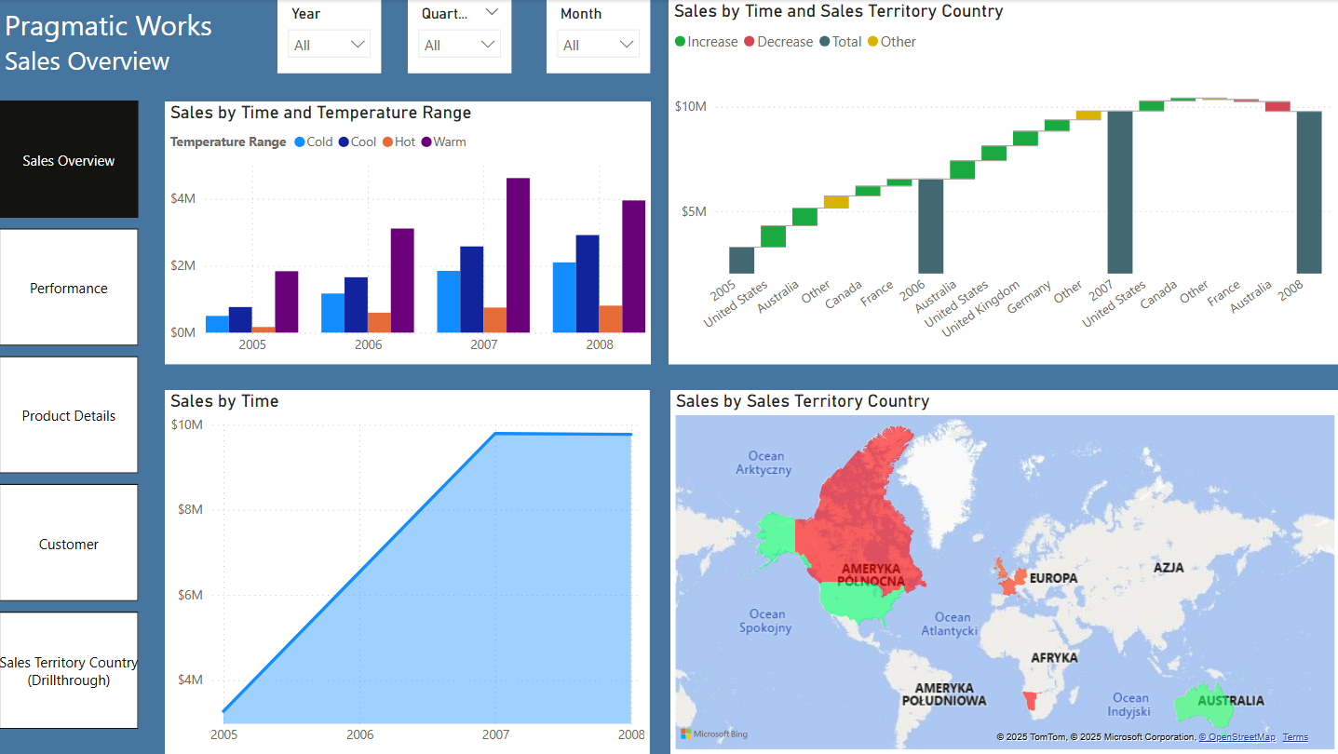
I have inserted Page Navigator Buttons on this page – when I click on Control and the name of any of the pages, I am directed to that page.
On this page I have analyzed Total Sales by Time, Temperature range and Sales territory country.
Sales by Time and Temperature Range:
I noticed that for all the years between 2005 and 2008 the highest sales took place during the warm temperature range, and the lowest sales – when it was hot.
Sales by Time:
On this visual (Area chart) I have used previously created Calendar hierarchy from Date table (Calendar Year, Calendar Quarter and Month Name) on X-axis. So, I can analyze sales by years, quarters and months.
Sales by year level:
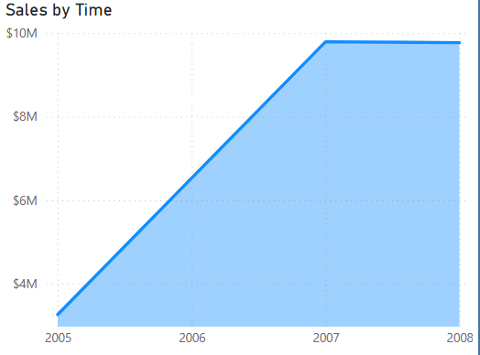
The highest sales were made in calendar years 2007 (around $ 9.79 million) and 2008 (around $ 9.77 million). Sales in 2007 were generated throughout the whole year, whereas in 2008 they were generated only from January till July. Therefore, to compare sales in 2007 and 2008, I considered the approach of Monthly Average Sales:
In 2007, sales were spread over 12 months:
Sum of sales in 2007 = $ 9,791,060.30
Average Monthly Sales in 2007 = $ 9,791,060.30 / 12 = $ 815,921.69
In 2008, sales were spread over 7 months:
Sum of sales in 2008 = 9,770,899.74
Average Monthly Sales in 2008 = $ 9,770,899.74 / 7 = $ 1,395,842.82
Conclusion: Average sales per month were significantly higher in 2008 than in 2007.

Sales by quarter’s level:

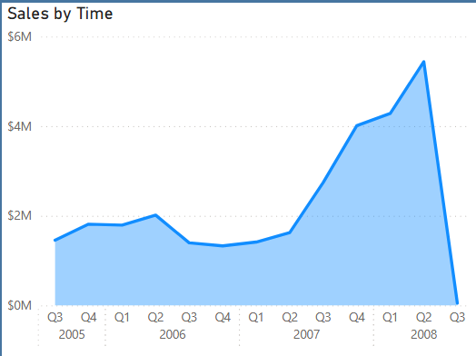
At the quarter’s level, the sales figures started to increase significantly from Q2 of 2007 (around $ 1.62 million) till Q2 of 2008 (around $ 5.44 million – the highest sales as far as quarter’s level is concerned).
Sales by month’s level:
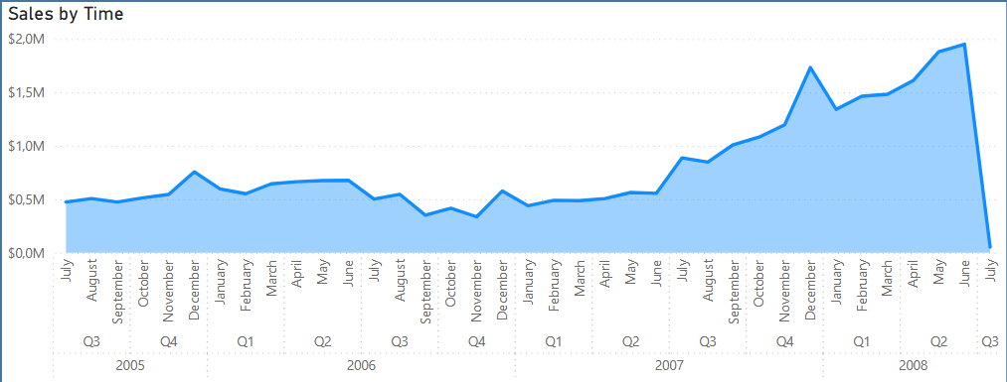

On a monthly level, sales showed an upward trend from June 2007 until June 2008. A significant increase was observed in December 2007, with sales reaching approximately $1.73 million. However, sales declined in January 2008 (this month’s sales were $1.34 million) before rebounding and peaking at around $1.95 million in June 2008.

Sales by Time and Sales Territory Country:
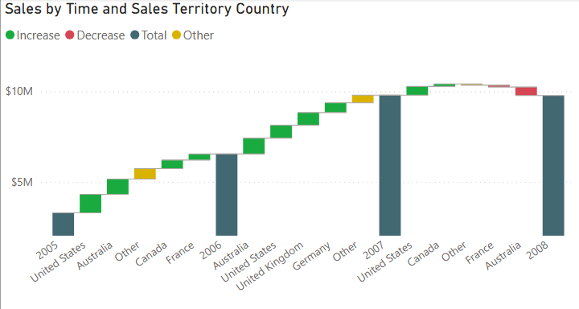
The above visual (Waterfall chart) shows which countries contributed to the increase (or decrease) in sales between consecutive years.
Maximum breakdown was set as 4:
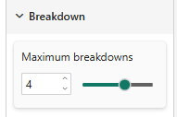
It means that the visual will show 4 most significant contributors to the change of sales – all the other countries will be presented in the category Other (marked in yellow on the visual).
The highest contributor in the increase of sales between the years 2005 and 2006 was United States. Australia took the second place. Between the years 2006 and 2007 Australia was the first country that contributed to the increase of sales, and United States the second one. Between the years 2007 and 2008 there was a slight decrease in sales. United States slightly increased of sales, whereas Australia dropped in sales.

Sales by Sales Territory Country (Filled map):
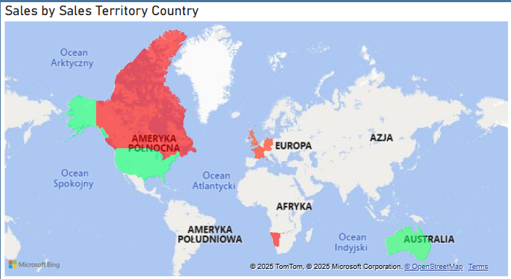
In Format I have set up the conditional formatting for Fill colors:
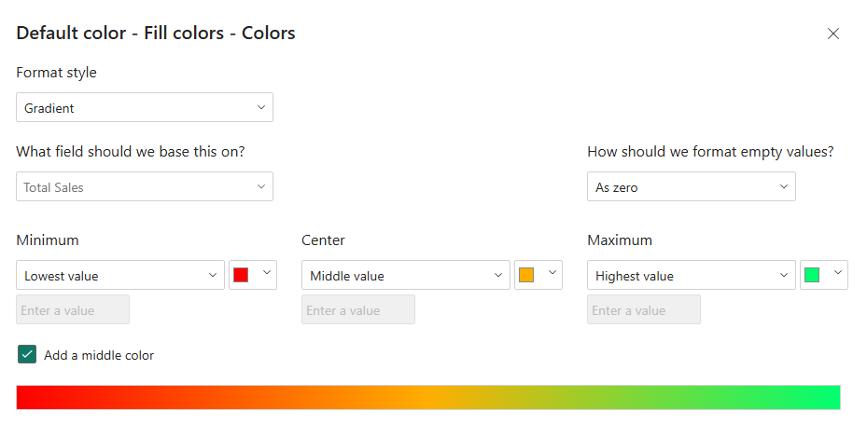
The lowest sales were presented in red on the map (Canada: around $ 1.98 million between 2005 and 2008) and the highest sales as green (United States: around $ 9.39 million and Australia: around $ 9.06 million - between 2005 and 2008).
  - Performance:
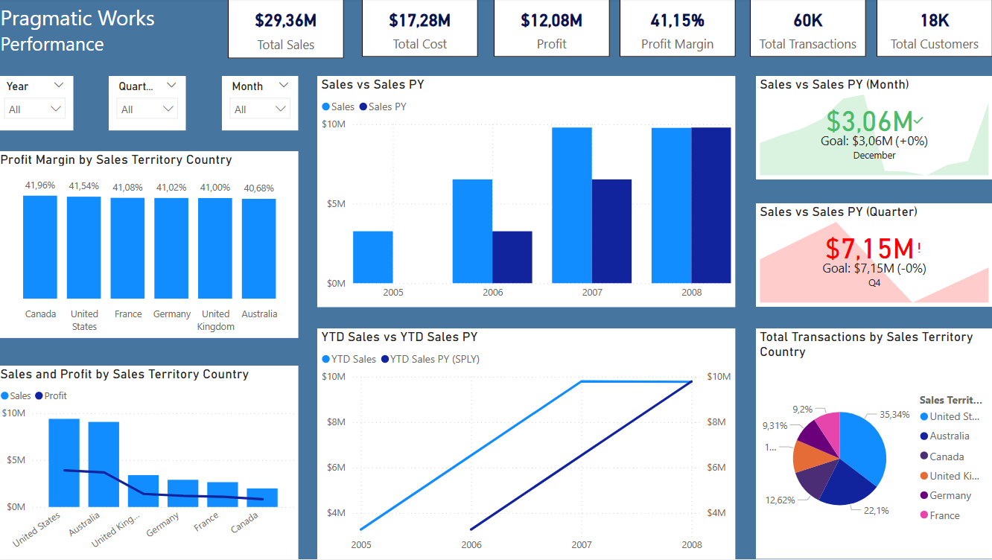

Main indicators in the analysis:

Total Sales (overall value: for all customers, all dates, all products, all sales territories etc.) = $ 29.36 million

Total Cost (overall value: for all customers, all dates, all products, all sales territories etc.) = $ 17.28 million

Profit (overall value: for all customers, all dates, all products, all sales territories etc.) = $ 12.08 million

Profit margin (overall value: for all customers, all dates, all products, all sales territories etc.) = 41.15 %

Total Transactions (overall value: for all customers, all dates, all products, all sales territories etc.) were around 60 thousand

Total Customers (overall value: for all dates, all products, all sales territories etc.) was around 18 thousand

Sales, Profit and Profit margin by Sales territory country
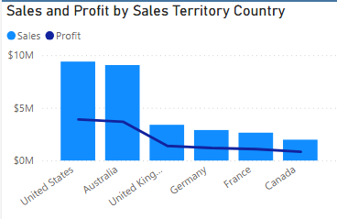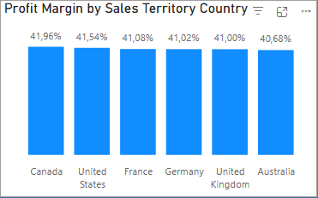
In the time period 2005-2008 the highest sales were made in United States (around $ 9.39 million). The second place took Australia (around $ 9.06 million). Profit margin was similar in all the countries (around 40%) – the highest profit margin in years 2005-2008 was generated by Canada (which had the lowest sales).

Comparing current-year Sales with prior-year Sales:
As sales were generated between July 2005 and July 2008, I will compare the current-year sales with prior-year sales on the quarter’s and month’s level (and not on the year’s level).
Quarter’s level:
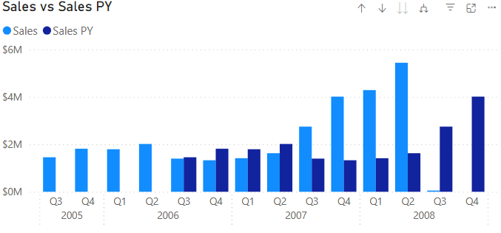
I compared sales with prior-year sales at the quarterly level and observed that from Q3 2006 to Q2 2007, current-year sales were slightly lower than those of the same quarter in the previous year. However, from Q3 2007 to Q2 2008, current-year sales were significantly higher than prior-year sales.
Month’s level:

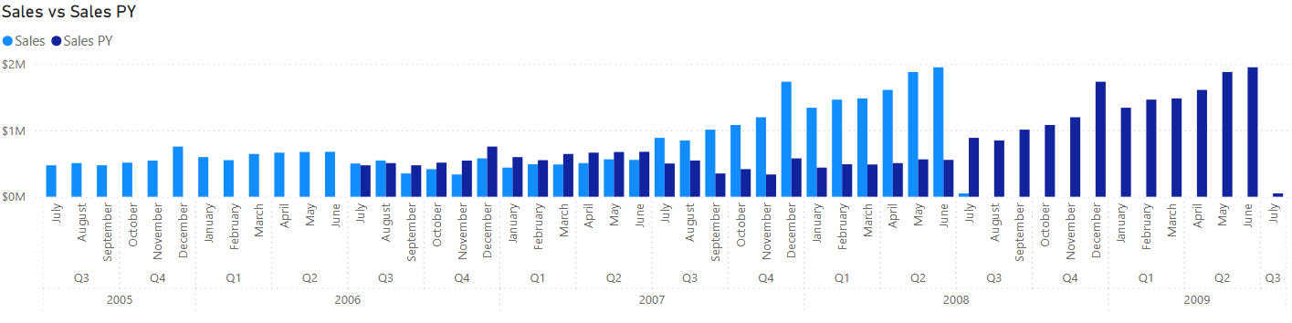
I compared sales with prior-year sales at the monthly level and observed that from September 2006 to June 2007, current-year sales were slightly lower than those of the same month in the previous year. However, from July 2007 to June 2008, current-year sales were significantly higher than prior-year sales.

Comparing current-year YTD Sales with prior-year YTD Sales:
As sales were generated between July 2005 and July 2008, I will compare the current-year YTD sales with prior-year YTD sales on the quarter’s and month’s level (and not on the year’s level).

Quarter’s level:
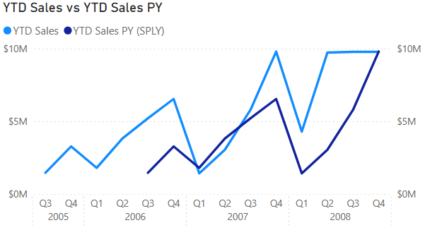
I analyzed year-to-date (YTD) sales by comparing each quarter's YTD sales in the current year with the corresponding quarter in the prior year, starting from Q1 2007. For example, I compared Q1 2007 (current year) with Q1 2006 (prior year), followed by Q2 2007 with Q2 2006, and so on.
I excluded earlier quarters to ensure a consistent comparison period. For instance, if I had compared Q4 2006 (current year) with Q4 2005 (prior year), the YTD sales would have reflected four quarters in 2006 (Q1–Q4) but only two quarters in 2005 (Q3–Q4), leading to an imbalance in the comparison.
I observed that year-to-date (YTD) sales in Q1 2007 and Q2 2007 were slightly lower than during the same periods in 2006. However, YTD sales began to increase in Q3 2007 compared to Q3 2006 and showed a significant increase in Q4 2007.
In 2008 (Q1 – Q2) I observed that the year-to-date (YTD) sales were significantly higher than during the same periods in 2007.
Month’s level:
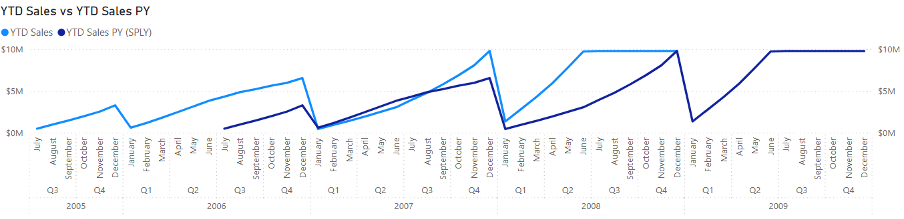
I analyzed year-to-date (YTD) sales by comparing each month's YTD sales in the current year with the corresponding month in the prior year, starting from January 2007. For example, I compared January 2007 (current year) with January 2006 (prior year), followed by February 2007 with February 2006, and so on.
I observed that year-to-date (YTD) sales between January and August 2007 were slightly lower than during the same periods in 2006. However, YTD sales began to increase in September 2007 (till December 2007) compared to the same period in 2006.
In 2008 (January – July) I observed that the year-to-date (YTD) sales were significantly higher than during the same periods in 2007.

2 KPI visualizations – interpretation:
KPI in general shows the comparison between the Value and Target. It indicates if the target was achieved for the specified period.
I used 2 KPI visualizations: I set them up as follows:
Value: Total Sales (for both KPIs)
Trend axis: Month for the first KPI; Calendar Quarter for the second one
Target: Total Sales Prior Year (for both KPIs)
I chose this Target to be able to see if the sales have increased between prior year and current year (for the specified month or quarter).
In Format (Trend axis) I chose the following Direction: High is good; as well as the colors: Good, Neutral and Bad:
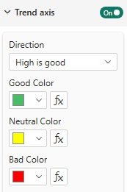
I used the slicers: Year and Quarter:
Example 1:

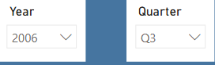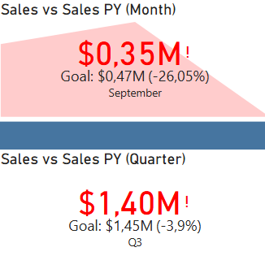
I chose Q3 and 2006 on the slicers. The interpretation is as follows:
The first KPI shows the comparison of Value (Total Sales in September 2006: $ 0.35 million) and Target (Total Sales in September 2005: $ 0.47 million). In this case September was shown as it is the last month in Q3 (If I have chosen just the year 2006 on the slicer, without choosing a quarter, December would be shown). The color is red, as the target has not been achieved.
The second KPI shows the comparison of Value (Total Sales in Q3 2006: $ 1.40 million) and Target (Total Sales in Q3 2005: $ 1.45 million). In this case Q3 was shown as it has been chosen in the slicer. (If I have chosen just the year 2006 on the slicer, without choosing a quarter, Q4 would be shown). The color is red, as the target has not been achieved.

Example 2:
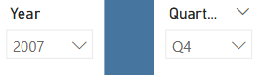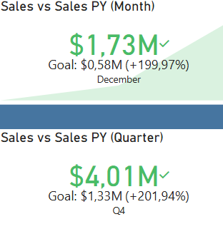

I chose Q4 and 2007 on the slicers. The interpretation is as follows:
The first KPI shows the comparison of Value (Total Sales in December 2007: $ 1.73 million) and Target (Total Sales in December 2006: $ 0.58 million). In this case December was shown as it is the last month in Q4. The color is green, as the target has been achieved.
The second KPI shows the comparison of Value (Total Sales in Q4 2007: $ 4.01 million) and Target (Total Sales in Q4 2006: $ 1.33 million). In this case Q4 was shown as it has been chosen in the slicer. The color is green, as the target has been achieved.

Total Transactions by Sales Territory Country
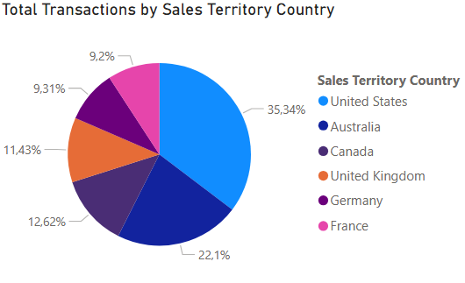
In the years 2005-2008 the highest number of transactions were performed in United States (35.34%). The second place was taken by Australia (22.1%). In this period those countries had also the highest sales and profit.

  - Product Details:
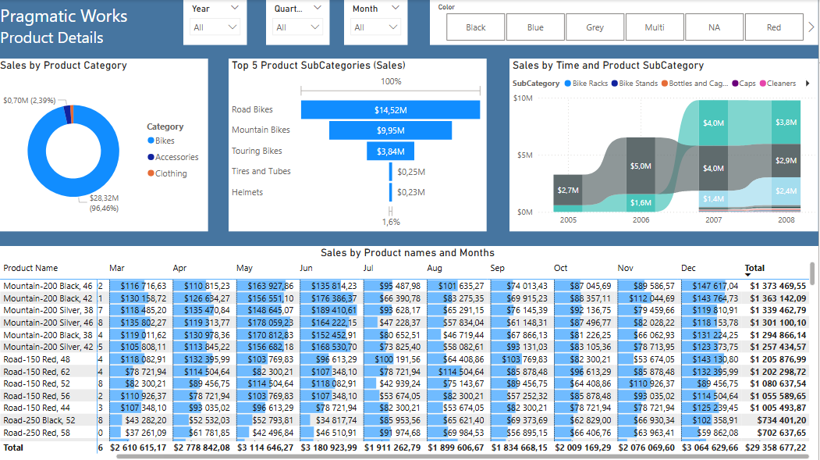

Sales by Product Category and Product Subcategory
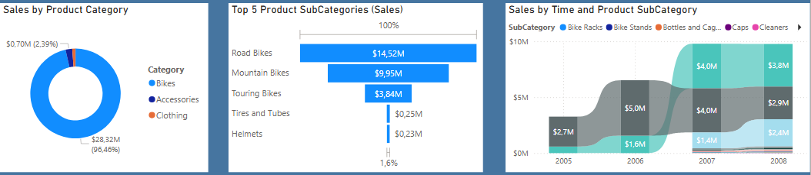
In the years 2005-2008 the product category Bikes generated 96.45% of all sales. Accessories and clothing together were just around 3.5% of the sales. In 2005 and 2006, Bikes were 100% of the sales. The other 2 product categories (Accessories and Clothing) started to be sold in 2007.
Concerning the product subcategory, most of the sales were generated by 3 subcategories: Road Bikes, Mountain Bikes and Touring Bikes. When we have a look at the product subcategories by year, in 2005 and 2006 the most popular were Road Bikes (Mountain Bikes on the second place), whereas in 2007 and 2008 the first product subcategory sold were Mountain Bikes and the second Road Bikes. Touring Bikes started to be sold in 2007.

Seasonal patterns in product demand
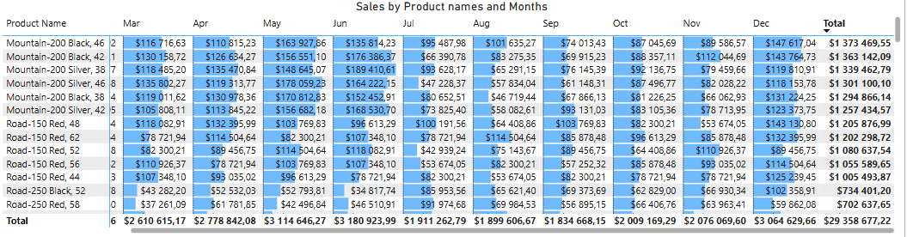 The highest demand for the products was observed during May, June and December.
The most popular product was Mountain-200 Black, 46, with total sales of around $ 1.37 million.

  - Customer:
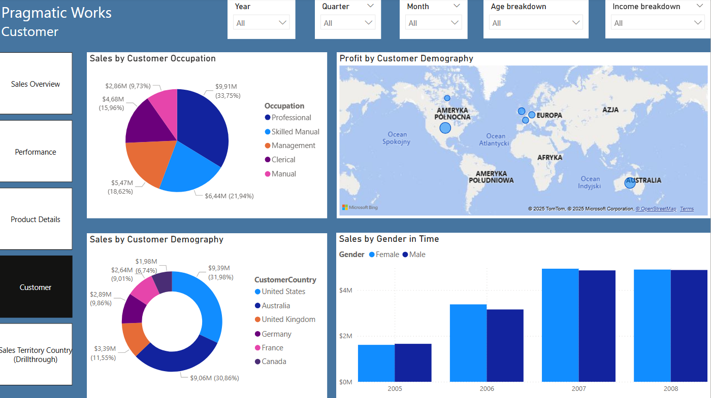
On this page I have analyzed Total Sales and Profits by different indicators concerning Customer.
To enhance the analysis, I utilized various slicers, including Year, Quarter, Month, Age Breakdown, and Income Breakdown. As a standard practice for slicer usage in the report, I chose not to synchronize slicers across report pages to ensure that selections on one page do not affect similar slicers on other pages:
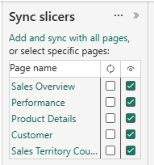
Sales by Customer Occupation (considering Age breakdown and Income breakdown)
Between 2005 and 2008, the highest sales were generated by customers in Professional occupations, accounting for 33.75% of total sales. Skilled Manual occupations ranked second with 21.94%, while the lowest sales were attributed to customers in Manual occupations, contributing 9.73%.
However, when analyzing sales by customer occupation across different age groups, the distribution varied significantly:
Ages 35-44: Customers in Manual occupations contributed approximately 50% of total sales, followed by Skilled Manual occupations at around 33%.
Ages 45-54: Professional occupations led with 28.56% of total sales, while Skilled Manual occupations ranked second at 25.61%.
Ages 55+: Professional occupations again generated the highest sales at 35.79%, followed by Management occupations at 21.39%.
When I took into consideration Income breakdown, I noticed that for customers with income more than $ 100 thousand, sales were generated mainly by customers with Management occupation (around 60%), then Professional occupation (around 40%). For customers with income $ 50-100 thousand, sales were generated mainly by customers with Professional occupation (54.83%), than by Skilled Manual (25.27%) and then Management occupation (around 20%).

Sales by Customer Demography (considering Age breakdown)
On this visual (Donut chart) I have used previously created Customer Geography hierarchy from Geography table (CustomerCountry, CustomerState, CustomerCity) as a Legend.
During the period of 2005 – 2008 the highest sales were generated by customers coming from United States (31.98%). Slightly smaller sales were generated by customers from Australia (30.86%). The lowest sales were generated by customers from Canada (6.74%).
However, when analyzing sales by customer demography across different age groups, I noticed that for age groups 35-44 and 45-54 sales were higher for customers from Australia (around 41% of all the sales for customers who are 35-54) than customers from United States (26.53% of all the sales for customers who are 35-54). For age group 55+ the highest sales were generated by customers from United States (33.83%), then by customers from Australia (27.41%).

Profit by Customer Demography
Concerning the profit during the period of 2005 – 2008, the highest was generated by customers coming from United States (around $ 3.9 million). Slightly smaller profit was generated by customers from Australia (around $ 3.69 million). The lowest profit was generated by customers from Canada (around $ 830 thousand).
I can observe the link between the total sales and profit (the countries with the highest sales had the highest profit, and the countries with the lowest sales had the lowest profit).

Sales by Gender in Time (considering Age breakdown and Income breakdown)
During the period of 2005 – 2008 I observed just the slight difference between sales generated by females and males.
However, when I analysed sales by gender for different Age breakdowns, I noticed that for the Age breakdown of 35-44 there was a significant difference between the sales generated by females and males in the years 2006 – 2008 (more sales done by males). For the other Age breakdowns, the differences between sales for males and females were smaller.
When I took into consideration Income breakdown, I noticed that for Income higher than $ 150 thousand there was a significant difference in sales between males and females: For the years 2006 and 2008 sales generated by males were significantly higher than by females. However, in 2007 females generated more sales than males. For the other Income breakdowns the differences in sales between males and females were not so significant.

  - Sales Territory Country (Drillthrough):
In this report page I could compare various data across different Sales territory countries – examples of United States, Australia and Canada below:
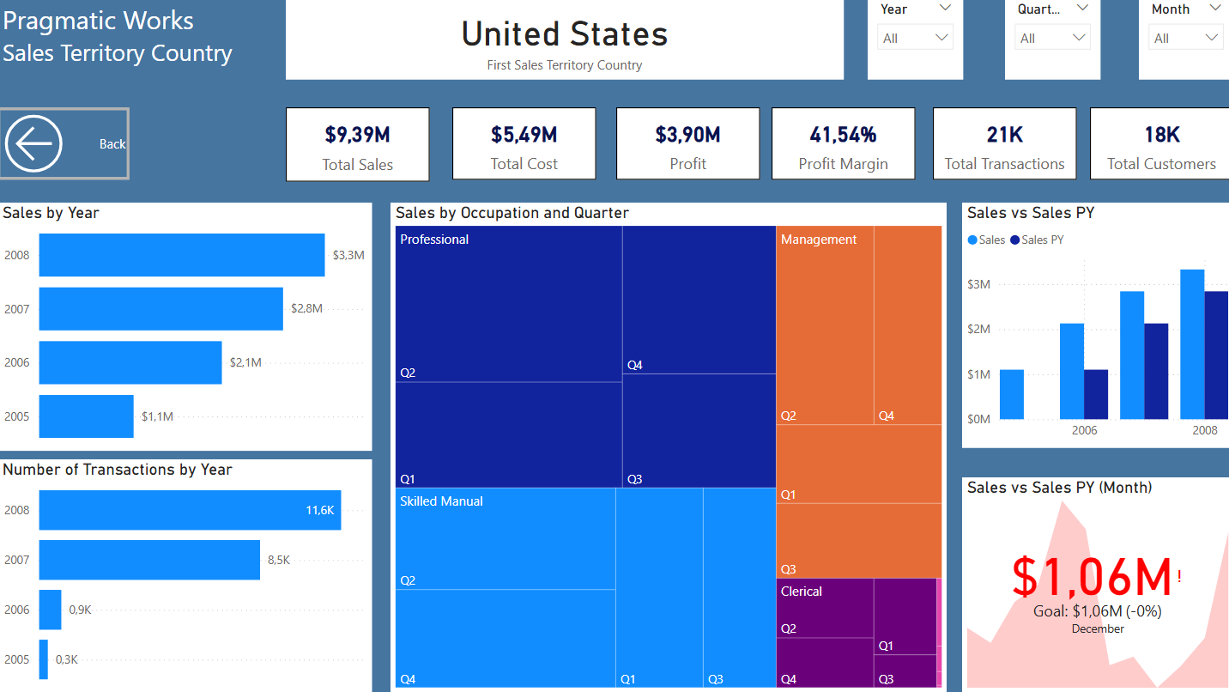
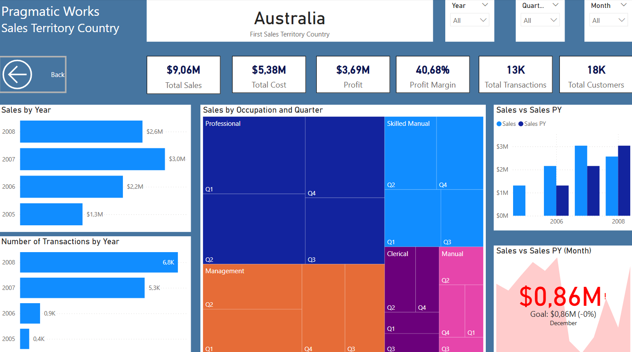
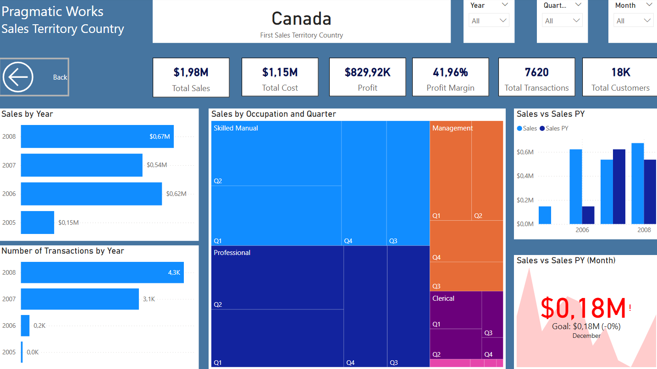

In Format (Page Information) I changed the Page type from Standard to Drillthrough:
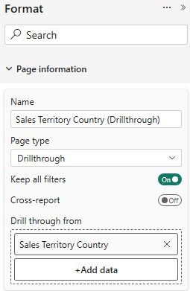
In the ‘Drill Through from’ field, I selected Sales Territory Country. As a result, when I right-click on any visual containing Sales Territory Country on other report pages and choose the Drill Through option followed by the name of the drill-through page, I am directed to that page. The visuals on the drill-through page will then display results specific to the selected Sales Territory Country.
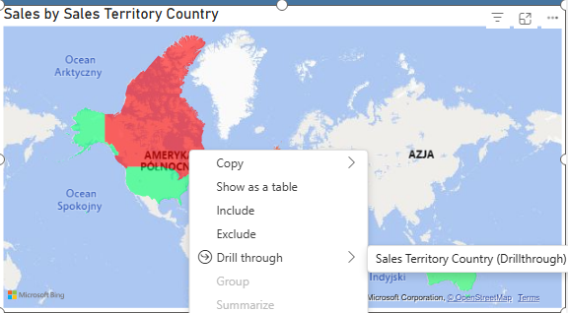

Conclusions and responses to Key Business Questions I investigated in the project:
- Which product categories and subcategories generate the most revenue? What was the most popular product in 2005 – 2008?

Bikes was the product category which generated the highest sales value between 2005 and 2008. Most of the sales were generated by 3 subcategories: Road Bikes, Mountain Bikes and Touring Bikes. Between 2005 and 2008 the most popular product was Mountain-200 Black, 46, with total sales of around $ 1.37 million.

- How do sales trends vary by sales region and customer demographics?
Regarding sales regions, the highest sales between 2005 and 2008 were recorded in the United States ($9.39 million) and Australia ($9.06 million). During this period, the United States also had the highest number of transactions, accounting for 35.34% of total transactions, followed by Australia with 22.1%. In contrast, Canada generated the lowest sales, totaling approximately $1.98 million.
In terms of customer demographics, the highest sales between 2005 and 2008 were attributed to customers from the United States (31.98%), followed by Australia (30.86%). Customers from Canada contributed the lowest sales, accounting for 6.74% of the total.

- What are the seasonal patterns in product demand?
The highest demand for the products was observed during May, June and December.

- When was the Peak Sales Period?
Between 2005 and 2008, total sales amounted to $29.36 million. The highest sales were recorded in 2007 ($ 9.79 million) and 2008 ($ 9.77 million). While sales in 2007 occurred throughout the entire year, sales in 2008 were generated within the first seven months (until July).
To compare performance, Average Monthly Sales were calculated:
- 2007: $ 815,921.69
- 2008: $ 1,395,842.82
This indicates that the average monthly sales in 2008 were significantly higher than in 2007.
On a quarterly level, sales increased notably from Q2 2007 ($ 1.62 million) to Q2 2008 ($ 5.44 million) – the highest quarterly sales recorded during this period.
On a monthly level, a significant spike occurred in December 2007 ($1.73 million), followed by a decline in January 2008 (till $ 1.34 million). Sales then rebounded, reaching their peak in June 2008 ($1.95 million).

- Did the temperature range have an impact on the sales volume?
Temperature range had an impact on the sales volume. In the period 2005 – 2008 the highest sales took place during the warm temperature range, and the lowest sales – when it was hot.

